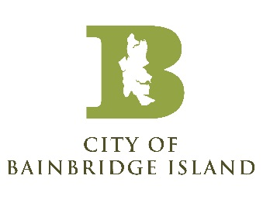

NOTICE OF CANCELED UTILITY ADVISORY COMMITTEE MEETING

The Utility Advisory Committee meeting for August 21st, 2025, has been canceled.

Posted: August 18th, 2025, City website and kiosks

