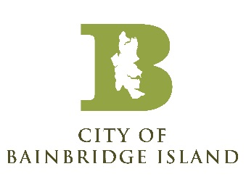

NOTICE OF CANCELED UTILITY ADVISORY COMMITTEE MEETING

The Utility Advisory Committee meeting for October 16th, 2025, has been canceled.

Posted: October 9th, 2025, City website and kiosks

