Groundwater Management Plan Discussion Paper

29 June 2018
(revised 24 October 2018)

By

Environmental Technical Advisory Committee: Frank Gremse (former chair and member, ETAC), Charlie Kratzer, Karl Shearer, Dylan Frazer, and Jason Flowers

New Members of ETAC after 6/29/18 draft: Melanie Kennan, Juan Rovalo, Steve Saepoff, and Casey Schmidt

Table of Contents

Introduction ..……………………………………………………………………………………………..1
Observations and Conclusions .………………………………………………………………………..1
Recommendations ………………………………………………………………………………………2
Appendix A: Bainbridge Island Aquifers’ Descriptions ……………………………………………...4
Appendix B: Aquifer Water Balance and Budget Issues ……………………………………………7
Appendix C: Water Level Measurements for Some Bainbridge Island Wells ………..…………12
Appendix D: Water Quality ………………………………………………………………..………….14
Appendix E: Modeling Forecasts ………………………………………………………..…………..16
Appendix F: References ………………………………………………………………..…………….19
Appendix G: Bainbridge Island Some COBI & KPUD Wells ……………………..……………….20
Appendix H: Groundwater Management Plan Content ………………………….…………………28
Appendix I: Groundwater Management Plan Experience ……………………….…………………31

List of Figures

Figure 1. Geologic Map – Part of Bainbridge Island ……………………………………….….…….4
Figure 2. Bainbridge Island: Partial Geologic Cross Section …………….………………….……..5
Figure 3. Annual Precipitation at SeaTac, 1980-2017 ………………………………………..…….8
Figure 4. Well Production History, 1995-2014 ……………………………………………….………9
Figure 5. Aspect Water Balance for 2005-14 conditions compared to projected conditions …..11

List of Tables

Table 1. Wells of Historic and/or Current Concern ………………………………………….……..12
Table 2. Water Level Trends for Some Bainbridge Island Wells (2007-2016) …………….……13
Table 3. DOE Hazardous Sites List – 21 Feb 2018 …………………………………………..……15
Table 4. USGS Projected Groundwater Level Fluctuation by 2035 ………………………..…….16

INTRODUCTION

Groundwater is the sole source of drinking water on Bainbridge Island. The increased demands for groundwater resulting from population growth and the anticipated effects of climate change have created concern about the sustainability of the island’s aquifers as well as the potential for saltwater intrusion. The Environmental Technical Advisory Committee (ETAC) was asked by the City Council to analyze the possible need for the development of a Groundwater Management Plan (GWMP). In addition, the City Council requested ETAC to recommend a scope and level-of-effort (e.g., budget, staffing needs) for the development of such a GWMP. To complete its assessment, ETAC reviewed the available information on the aquifers, aquifer modeling efforts, well hydrographs, and groundwater quality information. ETAC has summarized that information in this report.

OBSERVATIONS AND CONCLUSIONS

- Bainbridge Island has an abundance of technical information on its groundwater resource, including multiple comprehensive USGS reports on the hydrogeology of the island including groundwater models, plus several reports by Aspect, KPUD, and others.

- There is an ongoing groundwater monitoring program for island wells performed by COBI staff and KPUD. This monitoring program is essential to a GWMP and must be continued to keep track of what is happening with the island’s groundwater resource.

- Three of the six aquifers on Bainbridge Island: Perched, Sea Level and Fletcher Bay produce approximately 97% of the pumped well water.

- The Bedrock Aquifer in the southeast part of the island is not included in current Bainbridge Island groundwater model assessments and is not expected to be considered for significant water production. Pumping wells in this area should not be promoted and residences in this area of the island should be encouraged to obtain a connection with a water purveyor.

- The primary source (85-90 percent) of aquifer recharge is precipitation, with return flows from septic systems (5-10 percent) and off-island aquifer flow to the island (5 percent), being of significantly less importance.

- Well hydrographs from the existing monitoring well network and modeling efforts indicate that the Bainbridge Island aquifers are functioning at a level which is capable of meeting the present domestic and commercial withdrawal demands.

- Aspect’s modeling indicated that “predicted groundwater level changes over a 100-year modeling timeframe were less than the COBI Early Warning Levels (EWLs) but there may be detrimental effects on surface water features. EWLs are discussed in City of Bainbridge Island (2017).

- The groundwater withdrawal rates show a considerable degree of variability with time (over 100%) which shows that a number of environmental factors influence the withdrawal rates.

- The deficit between groundwater outflow and inflow is made up from the stored groundwater (termed aquifer storage). This means that a plan should be developed for those conditions of extended periods of low rainfall and for extended periods of drought where substantially more groundwater will be required to be withdrawn from aquifer storage.

- It is evident from available climate change information that our precipitation patterns are changing and will continue to change into our future. The present prediction for the Pacific Northwest is that the frequency of higher rainfall intensity will increase (Mauger and others, 2015) with a concomitant increase in runoff (Aspect, 2016a).

- Climate change could lead to more severe droughts. There is also the possibility of multi-year droughts, although the probability of this for the Pacific Northwest is presently deemed to be low.

- The Aspect modification of the USGS predictive model (Aspect, 2016a) did not predict a flow reversal in the Fletcher Bay Aquifer or the Sea Level Aquifer, plus it indicated that groundwater from the Bainbridge Island aquifer system would continue to flow to the shoreline in sufficient quantities to keep the freshwater/seawater interface at a distance from the Bainbridge Island shoreline (no seawater intrusion). USGS model results showed the same for expected conditions. Only the USGS model results for extreme conditions (worst climate change, full island and Kitsap Peninsula build out, and purposefully exaggerated population growth) projected a flow reversal in the Fletcher Bay Aquifer which USGS scientists reported could cause seawater intrusion to develop in time along the eastern and northern shorelines.

- An outline of GWMPs is included in Appendix H. Experience of a few counties with the development and implementation of GWMPs is presented in Appendix I.

RECOMMENDATIONS

Because of the critical nature of the island’s sole source aquifer, the development of a GWMP would be of great benefit to the island community. The development of the plan could follow several different paths, including:

- Apply to the Department of Ecology (DOE) for assistance in accordance with WAC 173-100 in the development of a GWMP. However, DOE has indicated to us that given their present work load and without a new funding source they do not have the resources to address this in the near term (approximately two years to initiate). Previous plans begun in the late 1980’s and 1990’s took up to 10 years to complete.

- COBI could initiate and lead the process either with in-house staff or with the assistance of a consultant. It is possible that COBI could obtain DOE’s assistance in bringing all the stakeholders to the table for the advisory committee to guide some of the development process. The abundance of information on the island’s groundwater resource means that pulling together the recommended informational elements of a GWMP would be primarily a matter of information mining and not information development. The advisory committee would then help with the goals, alternatives, recommendations, and implementation sections of the GWMP.

- Contact Kitsap PUD to determine their interest in leading or co-leading with COBI in the development of an Island-wide GWMP.

Areas which such a plan could address are:

- Community-wide education program concerning the state of the island’s aquifers.

- A feasibility analysis of the potential inter-operability of the island’s aquifers.

- Ensure that the well monitoring network is maintained (water extraction and seawater intrusion monitoring) and examined to see if it should be expanded, with the possibility of adding wells from private (exempt), Group A, and Group B water systems.

- Encourage the expansion of existing Group A (greater than 15 connections) water systems.

- Assess the impacts of proposed activities, development, and population growth on the streams and wetlands that are either sustained by groundwater discharge or contribute recharge to groundwater. Consider creation and application of one or more aquifer conservation zones.

- Encourage water re-use and reclamation.

- Develop a water conservation program.

- Develop a program that incentivizes and facilitates innovative methods for homeowners and business owners to use storm water and grey water.

- Develop a refined water budget for each aquifer (and therefore the system) with the incorporation of more robust modeling of groundwater/surface water interaction.

- Develop potential methods for funding initiatives and programs developed by the GWMP.

Appendix A: Bainbridge Island Aquifer Descriptions

Bainbridge Island is underlain by unconsolidated deposits of glacial and nonglacial origin. The USGS has identified the principal hydrogeologic units that determine its groundwater aquifer system (Haugerud, 2005). Frans and others (2011) present a detailed description of six aquifers on Bainbridge Island which are: perched aquifer, semi-perched aquifer, sea level aquifer, glaciomarine aquifer, Fletcher Bay aquifer and the bedrock aquifer. The three most significant aquifers on the island, based on water usage (97% of the water supply), are the Perched Aquifer, the Sea Level Aquifer and the Fletcher Bay Aquifer.

The first five aquifers described in the previous paragraph are not present in the southeast end of the island. The older uplifted formations in the southeast end (tan to pink in Figure 1 and grey in Figure 2) are considered bedrock, and thin porous intervals within these units collectively constitute the 'bedrock aquifer'. The bedrock is so geologically complex that mapping and modeling of aquifer units and predicting performance are not practical and come with large uncertainties. That is why they were not included in modeling studies. The thin bedrock aquifer layers are unlikely to support significant production. It is estimated that approximately 10 to 20 bedrock aquifer wells exist in this area.
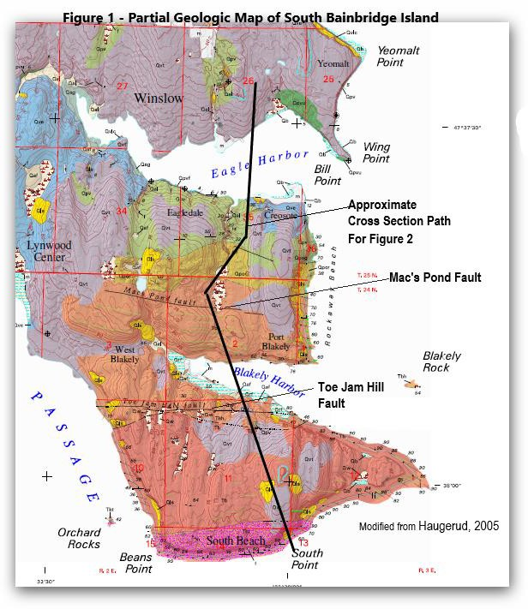

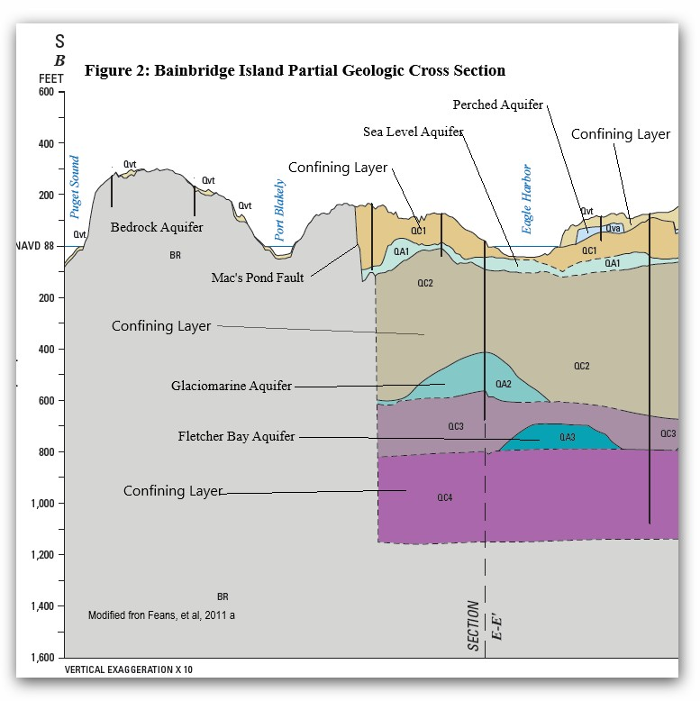

The Semi-Perched Aquifer is composed of locally continuous and mappable zones of permeable interbeds of sand and gravel. Where data was available, these interbeds are 10 to 50 feet thick. In the USGS study of Bainbridge Island, much of the previously mapped Semi- Perched Aquifer was shifted to the Perched Aquifer (Frans and others, 2011). The Glaciomarine Aquifer is a confined aquifer ranging in composition from sand and gravel to silt. However, few wells draw water from the Glaciomarine Aquifer due to its depth and generally lower permeability compared to the Perched Aquifer and Sea Level Aquifer.

The Perched Aquifer is mostly unconfined, consisting of well-sorted sand, or sand and gravel with lenses of silt and clay. It is a widely used aquifer with water levels ranging from sea level to 300 feet above sea level. It ranges in thickness from 20 to 200 feet, with most of the unit less than 100 feet in thickness. It is not believed to be connected to the Kitsap Peninsula. In a simulated water budget for 2008, the Perched Aquifer accounted for 14% of groundwater pumping on Bainbridge Island (Frans and others, 2011).

The Sea Level Aquifer is mostly confined, consisting of glacial sand and gravel with silt interbeds. It is a widely used aquifer with water levels ranging from 200 feet below sea level to 200 feet above sea level. It ranges in thickness from 25 to 200 feet. It is believed to extend beneath Port Orchard Bay to the Kitsap Peninsula. In a simulated water budget for 2008, Sea Level Aquifer accounted for 46% of groundwater pumping on Bainbridge Island (Frans and others, 2011).

The Fletcher Bay Aquifer is confined, consisting of sand and gravel with silt interbeds. It is used by a few large-scale COBI production wells. The top of Fletcher Bay Aquifer ranges from more than 900 feet below sea level to around 600 feet below sea level. Typical thicknesses are 50 to 300 feet. The Fletcher Bay Aquifer is believed to extend below Port Orchard Bay to the Kitsap Peninsula. In a simulated water budget for 2008, the Fletcher Bay Aquifer accounted for 38% of groundwater pumping on Bainbridge Island (Frans and others, 2011).

Appendix B: Aquifer Water Balance and Budget Issues

a. The water balance of an aquifer is the summation of the inflows minus the outflows. For Bainbridge Island, the inflows are primarily from surface water infiltration, septic system returns, and off-island aquifer water flow to the island. The outflows are primarily from pumping, seepage to island surface water, and aquifer water flow out of the aquifer (i.e. to Puget Sound). If the outflows exceed the inflows then the difference must be made up from the water stored in the aquifer system termed aquifer storage. Similarly, if the inflows exceed the outflows then the surplus will be added to the aquifer storage. Both of these scenarios have secondary effects on hydraulically-influenced outflows.

b. The basic equation representing an annual water balance for the aquifers on Bainbridge Island is:

GW_{in} + R_{ppt} + R_{sep} + S_{in} = GW_{out} + D_{sw} + D_{ppg} + S_{out} (1)

Where,

GW_{in} is lateral groundwater flow to the model area (from the Kitsap Peninsula);
R_{ppt} is recharge from precipitation;
R_{sep} is recharge from septic returns;
S_{in} is groundwater contributed from storage;
GW_{out} is lateral groundwater flow from the model area (to Puget Sound);
D_{sw} is discharge of groundwater to surface water on Bainbridge Island;
D_{ppg} is groundwater pumping from wells; and
S_{out} is groundwater going into storage.

In a stable aquifer over the long-term, inflows equal outflows and there is no change in storage (i.e., S_{in} equals S_{out}). The water balance in equation (1) indicates that for stability to continue, an increase in outflows (e.g., pumping) would require an equal increase in inflows (e.g., recharge). Likewise, a decrease in recharge with an increase in pumping would require a reduction in groundwater flows to Puget Sound and to surface water on Bainbridge Island.

c. The USGS found that lateral groundwater flow (GW_{in}) to Bainbridge Island from the Kitsap Peninsula under Port Orchard Bay was about 5 percent of the overall inputs to the groundwater system (Frans and others, 2011). Likewise, the recharge from septic returns R_{sep} was estimated by USGS as slightly over 1 inch per year across the island (see Frans and others, 2011, fig. 25). This value represents about 5-10 percent of the overall inputs to the groundwater system. Thus, on the average, recharge from precipitation represents about 85-90 percent of inputs to the groundwater system.

Unfortunately, unlike groundwater pumping, aquifer recharge cannot be measured directly. A variety of methods can be used to estimate aquifer recharge, with a resulting wide range of values. In the first USGS report (Frans and others, 2011), aquifer recharge on Bainbridge Island from precipitation was estimated using a deep-percolation model developed for a small basin on Bainbridge Island and extrapolated to the rest of Bainbridge Island based on regression relations with precipitation, land use, and soil types on other parts of Bainbridge Island (Frans and others, 2011). USGS used a different method to estimate recharge on Bainbridge Island from precipitation in their Kitsap County groundwater model (Welch and others, 2014). Aquifer recharge from precipitation was estimated using precipitation-recharge regression equations that incorporate the effects of surficial characteristics, such as the permeability of surficial soils, the hydrogeologic units they formed on, and land-cover characteristics. Dr. Matthew Bachmann of USGS was involved in both studies and suggests that the aquifer recharge estimates from the Kitsap County model are the more reliable ones (Matthew Bachmann, USGS Hydrologist, Tacoma, WA, mbachman@usgs.gov, written communication, 3/17/16). The average aquifer recharge estimate for Bainbridge Island using the Kitsap model is 11.31 inches per year, compared to 20.45 inches per year in the earlier Bainbridge Island study.

d. In their water budget for 2008, USGS found that groundwater pumping was only about 7 percent of the overall groundwater outflows. The natural discharge to Puget Sound (GW_{ou}t) was about 36 percent of the total outflows and the rest was flows to surface waters (D_{sw}). These groundwater discharges help to repel potential seawater intrusion (GW_{out}) and sustain streams, lakes, wetlands, and springs (D_{sw}). A significant increase in pumping over time would ultimately result in some loss of storage (with an attendant decline in water levels) and a decrease in the natural discharge of groundwater (GW_{out} and D_{sw}).

e. The components of the water balance equation which are most directly impacted by population growth on Bainbridge island are R_{ppt}, R_{sep}, and D_{ppg}. Recharge (R_{ppt} and R_{sep}) is primarily determined by land-based factors (such as, soil type and land use, septic return flows) and precipitation. While the land-based factors only change slowly from year to year, precipitation changes much more rapidly. The variability in precipitation as recorded at Seatac Airport is illustrated in figure 3.

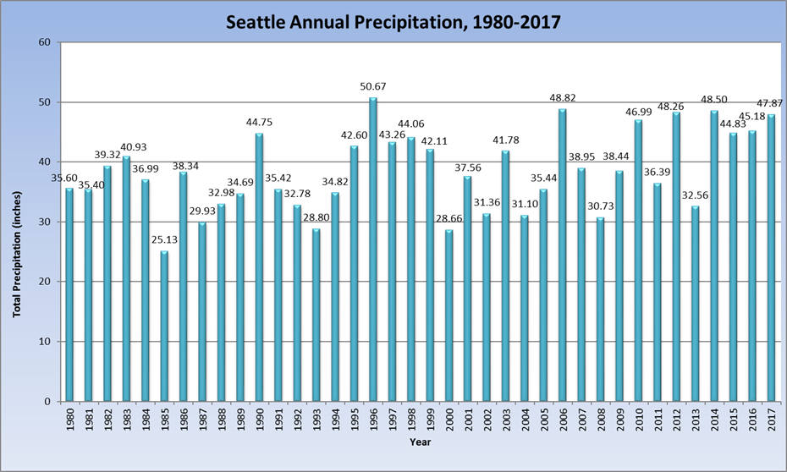

Figure 3. Annual Precipitation at Seatac Airport, 1980-2017

f. The pumping of groundwater, D_{ppg}, also varies considerably from year to year. In addition to the annual variations due to climatic factors, there is also an overall increase occurring on Bainbridge Island due to increased demand, primarily for meeting the needs of an increasing population. The D_{ppg} values are a combination of measurements and estimates. Pumping values for relatively large wells from water purveyors are measured and reported. However, about half the wells on the island are exempt from reporting because they are smaller domestic wells serving fewer than 15 connections. The pumping from these wells is estimated based on use per person estimates, persons per connection assumptions, and population estimates for Bainbridge Island. The reported pumping for 1995 to 2014 illustrates the considerable degree of seasonal and annual variability (see figure 4).

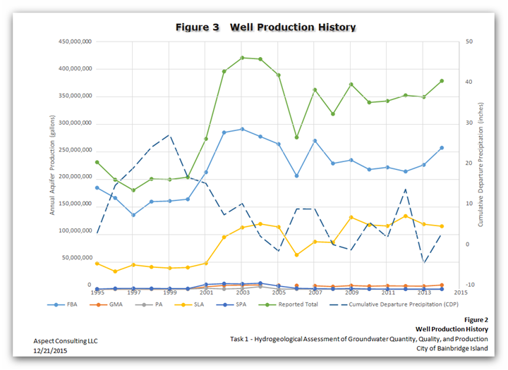
Figure 4. Well Production History, 1995-2014

g. In the 2011 USGS study of the Bainbridge Island aquifers (Frans and others, 2011), the USGS used data from over 400 wells to develop a groundwater model, and used synoptic measurements from over 100 wells and 20 streamflow-measurement stations to calibrate the model. Water balance conditions were developed for 2008 using the USGS model and are compared with “predevelopment” values. In general, the introduction of groundwater pumping on Bainbridge Island has resulted in a significant reduction (15-20 percent according to USGS model results) in the natural outflow of groundwater to island surface waters and to Puget Sound.

h. In 2015, Aspect reviewed and revised the 2011 USGS modeling effort (Aspect 2015b). In Aspect’s model revision they made changes in three areas to the USGS approach:

- Revised the Precipitation Recharge Rate: Aspect used the precipitation recharge rate from the 2014 USGS Kitsap model (Welch and others, 2014) which is approximately 79% lower than what the 2011 USGS model used (11.31 inches per year versus 20.45 inches per year). Aspect also removed the septic system return flows from their modeling.

- Updated Well Pumping Rates: Aspect used the same well pumping data as USGS for 2004 through 2008. In addition, Aspect used actual measured well pumping rates from COBI and KPUD wells for the years 2009 through 2014. Pumping rates for all other wells (Group A, B, and domestic water supply wells) were assigned the same monthly averages used by the USGS.

- Revised Modeling Approach: Aspect implemented several other modifications to the USGS modeling approach. These modifications included: correcting mean sea level designation; setting a no-flow boundary condition between the island and Puget Sound; removing potential double-counting of precipitation recharge from lakes; revising the groundwater flow algorithm; and using improved topographic data from a 2015 LiDAR database. Aspect also ran the model out 100 years from present as opposed to just year 2035, to allow a more critical approach to evaluating potential seawater intrusion, which may take a longer timeframe in which to occur as well as to improve model stability.

i. If we rewrite equation 1 in terms of changes (see equation 2 below), it can be used to solve for the changes in groundwater discharges to Puget Sound (GW_{in} – GW_{out}) and to surface water (D_{sw}) which would occur in the future.

GW_{in} + R_{ppt} + R_{sep} + S_{in} = GW_{out} + D_{sw} + D_{ppg} + S_{out} (1)

(GW_{in} – GW_{out}) + Change in R – Change in Pumping – Change in D_{sw} = Change in Storage (2)

Aspect compared the current (average 2005-14) water balance for Bainbridge Island with a future water balance that incorporates two possible future changes:

- A 50% increase in groundwater pumping to accommodate population growth
- A 20% decrease in recharge from precipitation to represent changes due to climate change and an increase in impervious surfaces on the island

The Aspect water balance (figure 5) includes no Change in Storage in current conditions and a very small Change in Storage in the future (-15 million gallons per year (MG/yr)) (Aspect, 2016a). This future value seems at odds with the statement in Aspect (2016a, page 9) that there will be a decrease in storage of 11,000 MG in groundwater storage in the future. The difference in recharge between current and future conditions is -796 MG/yr, reflecting the 20% decrease in recharge. The difference in pumping between current and future conditions is +417 MG/yr, reflecting the 50% increase in pumping. As a result of these changes in recharge and pumping, the difference in groundwater discharge to Puget Sound, (GW_{in} – GW_{out}), between current and future conditions is shown as +689 MG/yr and the difference in groundwater drainage to surface water, D_{sw,} between current and future conditions is -510 MG/yr. Both of these reductions in groundwater discharge are the result of lower water levels which are not fully reflected in the -15 MG/yr value for the Change in Storage. This resulting water balance should be refined to better distribute the changes between the three components of the water balance: GW_{in} – Gw_{out}; D_{sw}; and Change in Storage. Nevertheless, figure 5 provides a useful indication of the potential impact of the given scenario on future water levels and the resulting impact on groundwater discharges to Puget Sound for repelling saltwater intrusion and discharges to surface water to maintain wetlands, streams, lakes, and springs on the island.

Figure 5. Aspect water balance for 2005-14 conditions compared to projected conditions

Appendix C: Water Level Measurements for Some Bainbridge Island Wells

a. In Table 1 (Apfelbeck, 2018) presents information on wells of historic and/or current concern. The table shows that four of these five island wells are withdrawing water from Fletcher Bay Aquifer. This is important because Fletcher Bay Aquifer supplies approximately 32% of the island’s groundwater. If those wells fail in any way, it would be a significant burden on the island. In 2017 Aspect in conjunction with COBI and KPUD conducted a field test from January through April 2017 where production was temporarily transferred from the Fletcher Bay Aquifer to the Sea Level Aquifer. The water levels in the wells recovered to a normal level. This field test points to the possibility that a plan could be developed for the use of the aquifers in an interrelated fashion to address possible deficiencies in any one aquifer.

Table 1. Wells of Historic and/or Current Concern
Well | Aquifer | Historic Well Water Levels through 2008¹ | 2007-2016 Well Water Levels²
North Bainbridge Well 7 | Sea Level | Exhibited long-term decline 1995 through 2005 not consistent with rainfall patterns and attributed to production; at that time pumping from this well was reduced; as static water levels showed a relatively rapid recovery to pre-pumping levels when pumping reduced and water levels observed in nearby wells 3 and 6 did not show the same pattern of decline, the decline in 7 was determined to be localized to the well and not an aquifer condition. | Not of concern at this time; 0.39 feet water level rise per year; production remains fairly steady
North Bainbridge Well 9 | Fletcher Bay | Decline 1994 - 2000 suggests production may have exceeded recharge; 2000-2005 levels consistent with rainfall patterns; stable since 2005 | Not of concern at this time; questionable data indicated 0.4 feet of water level decline per year; however, KPUD hydrogeologist reported continuous data that was not vetted in time for the assessment indicates no decline; the continuous data will be included in this year's assessment
Sands Road 1 | Fletcher Bay | Decline 1994 - 2000 suggests production may have exceeded recharge; 2000-2005 levels consistent with rainfall patterns; stable since 2005 | Not of concern at this time; negligible decline of 0.08 feet per year
Sands Road 2 | Fletcher Bay | Decline 1994 - 2000 suggests production may have exceeded recharge; 2000-2005 levels consistent with rainfall patterns; stable since 2005 | Not of concern at this time; 0.37 feet water level rise per year
Island Utilities Well 1 | Fletcher Bay | Declined about 15 feet since 1988; exceeds Early Warning Level | Continues to exceed Early Warning Level and of immediate concern; 0.69 feet water level decline per year; KPUD hydrogeologist reports decline localized to this well and increased monitoring in wells 1, 2 and 3 to build better water level and production data to discern cause and design appropriate action
¹Groundwater Monitoring Program-Program Update, Aspect Consulting, LLC, March 2009
²Groundwater Monitoring Program Early Warning Level Assessment (2016), COBI, July 2017

b. COBI conducted early warning level (EWL) assessments of hydrographs from 71 wells in the monitoring network for which they monitored water level. Their results are summarized in Table 2 (City of Bainbridge Island, 2017). The term “trends” was modified here to “changes”, as trends denotes a statistical test for level of significance which was not done in the report. Note that some of the wells had insufficient data to evaluate changes over the decadal period. Also, the methodology of looking at an ordinary least squares fit through the data is very dependent upon the beginning and ending periods. In this case, the first three years of the decadal period had below normal precipitation and the last three years had above normal precipitation. This would tend to skew the results toward increases in water levels. An assessment using a longer time period and statistical techniques that provide p-values for the trendlines would provide better information. Nevertheless, the results of the COBI analysis show that 53 wells had increasing water levels and 14 had decreasing water levels over the decadal period.

Table 2. Water Level Changes for Some Bainbridge Island Wells (2007-2016)

Aquifers | No. of Monitoring Wells | Increasing Change | Decreasing Change
Perched Aquifer | 16 | 15 | 1
Semi-Perched | 8 | 7 | 1
Sea Level | 29 | 22 | 7
Glaciomarine | 5 | 4 | 1
Fletcher Bay | 9 | 5 | 4
Total | 67 | 53 | 14

Appendix D: Water Quality

a. The two main concerns for Bainbridge Island’s water quality are chloride and nitrate. Increased chloride levels are indicators of potential seawater intrusion into the aquifers, while increased nitrate levels in the groundwater are associated with potential septic system failure or the presence of fertilizers from overapplication in the well recharge area. In addition, discrete hazardous chemical releases can often impact local groundwater quality. The following sections discuss the data collected to date.

b. Aspect’s 2015 assessment of water quality data reported that results did not exceed the EWL of 100 milligrams per liter (mg/L) nor exhibit an increasing trend for chloride. Also, the assessment reported that water quality data did not exceed the U.S. Environmental Protection Agency’s (EPA) Maximum Contaminant Level (MCL) of 10 mg/L for nitrate.

c. Chloride measurements were also reviewed for data collected between 2007 and 2016 (City of Bainbridge Island, 2017). No chloride concentrations measured for this assessment period exceeded the EWL of 100 mg/L. Chloride concentrations in all aquifers were low (usually less than 21 mg/L). There have been isolated occurrences of high chloride concentration measurements. For example, in 2006, chloride concentration in the Seabold Water Association drinking water supply well exceeded the city’s EWL for potential seawater intrusion. Eleven wells in the area of the Seabold well were analyzed and no evidence of seawater intrusion was found (Sebren and others 2018). Also, at present there is no evidence to indicate that sea water intrusion is occurring on the island.

As shown in Table 3 from the WA Dept. of Ecology, there are a number of contaminated cleanup sites on Bainbridge Island. Thus, there exists a potential for contamination to seep into the aquifers and/or into the wellheads. The information presented in the table uses the Washington Ranking Method (WARM) to yield a score (a number between 1 and 5). A score of 1 represents the highest level of risk and 5 the lowest. Generally, Federal Superfund sites and sites ranked 1 or 2 are higher priority for cleanup. Factors that enter into site hazard ranking include: the amount and type of contaminants present, how easily contaminants could come into contact with people and the environment, and the level of public concern. Because several sites are given a rank of 2, it is important that groundwater quality parameters continue to be monitored to ensure the potability of the island’s groundwater.

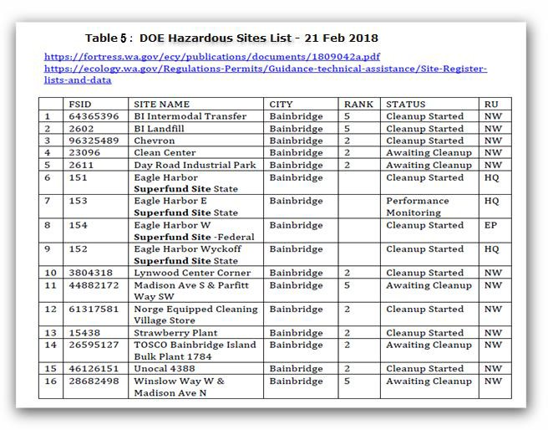

Table 3. DOE Hazardous Sites List, February 21, 2018

Appendix E: Modeling Forecasts

a. In Appendix B, “Aquifer Water Balance and Budget”, there is a description of the USGS model developed and calibrated for Bainbridge Island (Frans, and others, 2011b). For the three primary aquifers, the USGS used the model to simulate the possible effects of increased groundwater pumping and changes to recharge due to changes in land use and climactic conditions between 2008 and 2035 under minimal, expected, and maximum impact conditions. They found maximum drawdown levels to be 0-10 ft (0 – 0.37 ft/yr) for most of the Island for the minimal and expected impact scenarios (Table 4). The maximum impact scenario applied exaggerated population growth, full island and Kitsap Peninsula build out, and the most severe climate change conditions (sea level rise and rainfall runoff). For this scenario drawdown levels for most areas in all three aquifers were still less than 10 feet (or 0.37 ft/yr). However, isolated areas in the Perched and Sea Level Aquifers had steeper declines of between 15 – 20 feet, and isolated areas in the Fletcher Bay Aquifer showed declines of up to 40 feet.

b. For the maximum scenario for 2035, the model projected that direction of flow in the deep Fletcher Bay Aquifer would reverse and flow from east to west.

c. Although the model did not predict seawater intrusion by 2035 under any of the scenarios, USGS reported that continued exposure to the maximum conditions would likely result in seawater intrusion in the Fletcher Bay Aquifer along the northern and eastern coastlines at some undefined future date.

d. The water budget developed by USGS showed that about 50% of groundwater discharge is to surface waters (streams, lakes, springs, etc.) on the island, about 33% is to Puget Sound, and about 7% is to groundwater pumping (Frans, and others, 2011b).

Table 4: USGS Projected Groundwater Level Fluctuation by 2035
Aquifer | Minimum | Expected | Maximum¹
Perched Aquifer | For most of the aquifer, increases of as much as 5 ft or decreases less than 5 ft; slightly more than 10 ft decrease near Lynwood Center (Figure 39A, page 82). | 0-5 ft decrease for most of the aquifer; one isolated pocket of up to 25 ft decrease in southwest near Lynwood Center (Figure 37A, page 78). | Some areas increase as much as 5 ft; decreases  < 10 ft for most of the aquifer with isolated pockets of declines that exceed 15-20 ft (Figure 40A, page 86).

Sea-level Aquifer | Much of the aquifer will have increases of as much as 5 ft. Decreases of less than 5 ft in areas north of Eagle Harbor, south of Fletcher Bay, and from Manzanita Bay to Port Madison; decreases from 15-20 feet near Lynwood Center (Figure 39B, page 83). | 0-5 ft decrease for most of the central and northern areas with isolated pockets of declines between 10-20 ft near Lynwood Center and south of Port Madison; isolated increases up to 5 ft northwest of Murden Cove, south of Eagle Harbor, and along the western coastline (Figure  37B, page 79). | Decreases < 10 ft for most of the aquifer. Some level decrease between 10-20ft with isolated pockets in excess of 20 ft near Port Madison and Lynwood Center (Figure 40B, page 87).
Fletcher Bay Aquifer | Decreases of up to 5 ft mostly in the southwestern part of the unit around Eagle Harbor, Fletcher Bay, and south Manzanita Bay (Figure 39C, page 84). | Decreases range from < 4 ft in the northeast to 10 ft on the western side of the Island (Figure 37C, page 80). | Declines range from a minimum of 10 ft in the northeast corner of the Island to more than 40 ft on the western edge of the Island (Figure 40C, page 88).
1. The maximum impact scenario represents purposely exaggerated population growth, full Island build out, and the most severe reduction in recharge, but does not reflect anticipated conditions.

e. Aspect also modeled Bainbridge Island aquifers with certain refinements with respect to the USGS 2011 modeling effort (Aspect 2016). The model was run for a 100- year time frame and found the following results:

- The Perched Aquifer system showed an average 0.10 foot per year of water level decrease at 25 locations simulated across the Island;

- The Semi-Perched Aquifer system showed an average 0.13 foot per year of water level decrease at 12 locations simulated across the Island;

- The Sea Level Aquifer system showed an average 0.09 foot per year of water level decrease at 49 locations simulated across the Island;

- The Glaciomarine Aquifer showed an average 0.02 foot per year of water level decrease at 6 locations simulated across the Island; and

- The Fletcher Bay Aquifer showed an average 0.15 foot per year of water level decrease at 9 locations simulated across the Island.

- Water decreases above reflect aquifer storage reduced by approximately 11,000 million gallons between current and future conditions.

- The predictive model results did not demonstrate a flow reversal in the Fletcher Bay Aquifer, and indicated that groundwater from the Bainbridge Island aquifer system continued to flow to the shoreline, keeping the freshwater/seawater interface at a distance from the Bainbridge Island shoreline (no seawater intrusion).

- Aspect found that with increased groundwater withdrawal the total discharge of groundwater to surface waters features would decrease by up to 40%. It is important to note that this is a very gross estimate, because the limited grid resolution may not be sufficient to accurately simulate groundwater discharge to surface water and the model has not been calibrated to observed flows. However, potential reduced stream flow and lake and wetland volumes are important factors which should be included in future planning.

- It is important to note that there are a number of assumptions underlying Aspects development of their predictions (both positive and negative). A plan should be developed to help insure that the adverse effects realized under the conditions are not realized.

Appendix F: References

Apfelbeck, C., 2018, Comments on Groundwater Management Plan Discussion Paper, City of Bainbridge Island, Public Works, Groundwater Management Program (April 20, 2018).

City of Bainbridge Island, 2017, Groundwater Monitoring Program Early Warning Level Assessment (2016), Prepared by Cami Apfelbeck and Christian Berg, Water Resources Program. (available online at: http://www.ci.bainbridge-isl.wa.us/DocumentCenter/View/10883/)

Aspect, 2015a, Hydrogeological Assessment of Groundwater Quantity, Quality, and Production (Task 1), Prepared for the City of Bainbridge Island, December 21, 2015.

Aspect, 2015b, Bainbridge Island Groundwater Model: Review Findings and Recommendations (Task 2) and Critical Aquifer Recharge Area Assessment (Task 3 Scenario), Prepared for the City of Bainbridge Island, December 21, 2015.

Aspect, 2016a, Bainbridge Island Groundwater Model: Aquifer System Carrying Capacity Assessment (Task 3), Prepared for the City of Bainbridge Island, revised March 25, 2016.

Aspect, 2016b, Bainbridge Island Groundwater Model: Modeling Support for Operational Scenario Analysis, Prepared for the City of Bainbridge Island and Kitsap Public Utility District, December 2, 2016.

Aspect, 2017, Groundwater Production Field Test Summary and Comparison, Prepared for the City of Bainbridge Island and Kitsap Public Utility District, September 1, 2017.

Frans, L.M., Bachmann, M.P., Sumioka, S.S., and Olsen, T.D., 2011, Conceptual model and numerical simulation of the groundwater-flow system of Bainbridge Island, Washington: U.S. Geological Survey Scientific Investigations Report 2011-5021, 96 p. (available online at: https://pubs.usgs.gov/sir/2011/5021/)

Haugerud, Ralph A., Preliminary Geologic Map of Bainbridge Island, Washington: U.S. Geological Survey Open-File Report 2005-1387. (available online at: https://pubs.er.usgs.gov/publication/ofr20051387)

Kato & Warren, Inc., and Robinson & Noble, Inc., 2000, City of Bainbridge Island Level II Assessment: An Element of the Water Resources Study, December 2000.

Mauger, G.S., J.H. Casola, H.A. Morgan, R.L. Strauch, B. Jones, B. Curry, T.M. Busch Isaksen, L Whitely Binder, M.B. Krosby, and A.K. Snover, 2015, State of Knowledge: Climate Change in Puget Sound. Report prepared for the Puget Sound Partnership and the National Oceanic and Atmospheric Administration. Climate Impacts Group, University of Washington, Seattle. doi:10.7915/CIG93777D.

Sebren, Martin, Joel Purdy, Mark Morgan, Eric Evans, John Kiess, Cami Apfelbeck, Christian Berg, 2018, Seabold Potential Seawater Intrusion Investigation, May 2018.

Welch, W.B., Frans, L.M., and Olsen, T.D., 2014, Hydrogeologic framework, groundwater movement, and water budget of the Kitsap Peninsula, west-central Washington: U.S. Geological Survey Scientific Investigations Report 2014-5106, 44 p. (available online at: https://pubs.usgs.gov/sir/2014/5106/)
Appendix G: Bainbridge Island Some COBI & KPUD Wells

References: http://kpudhydrodata.kpud.org/APSFED_WELLS.aspx

COBI Well Monitoring Network Database - SCADA

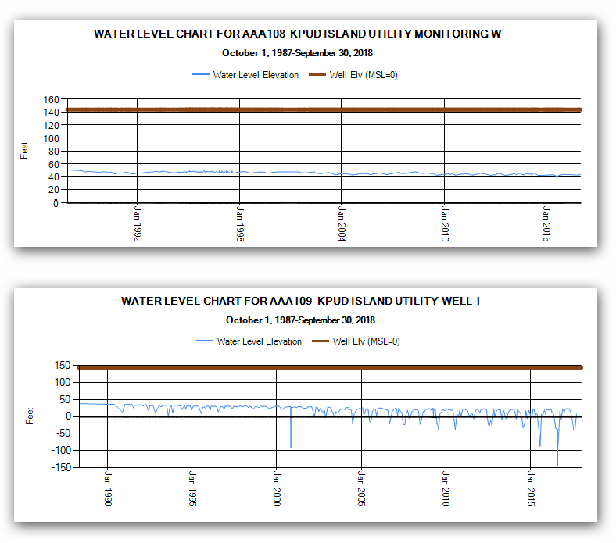

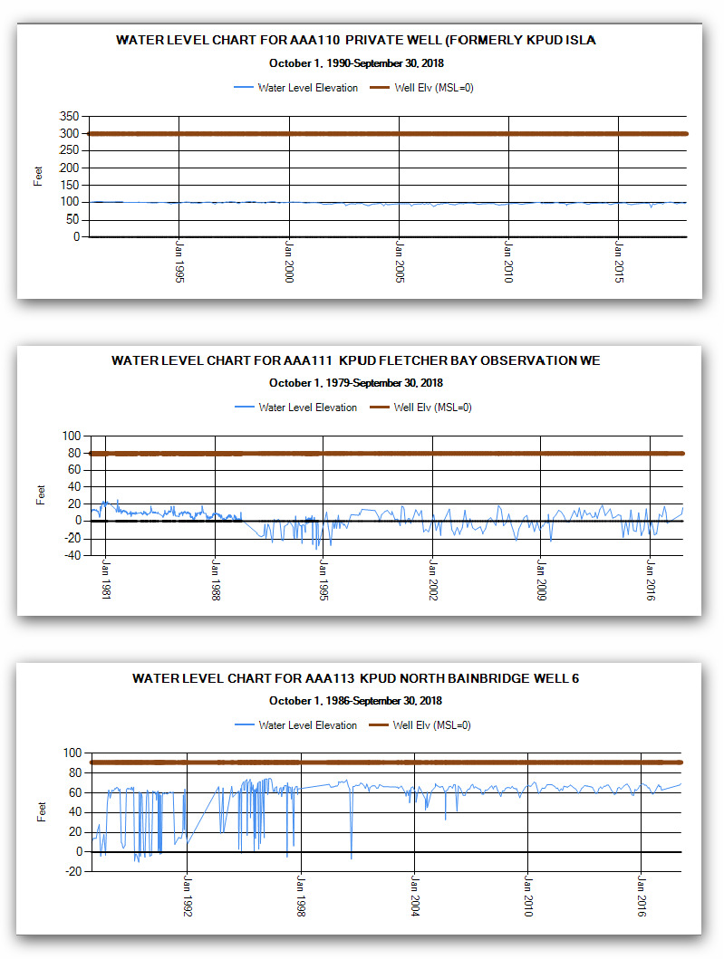

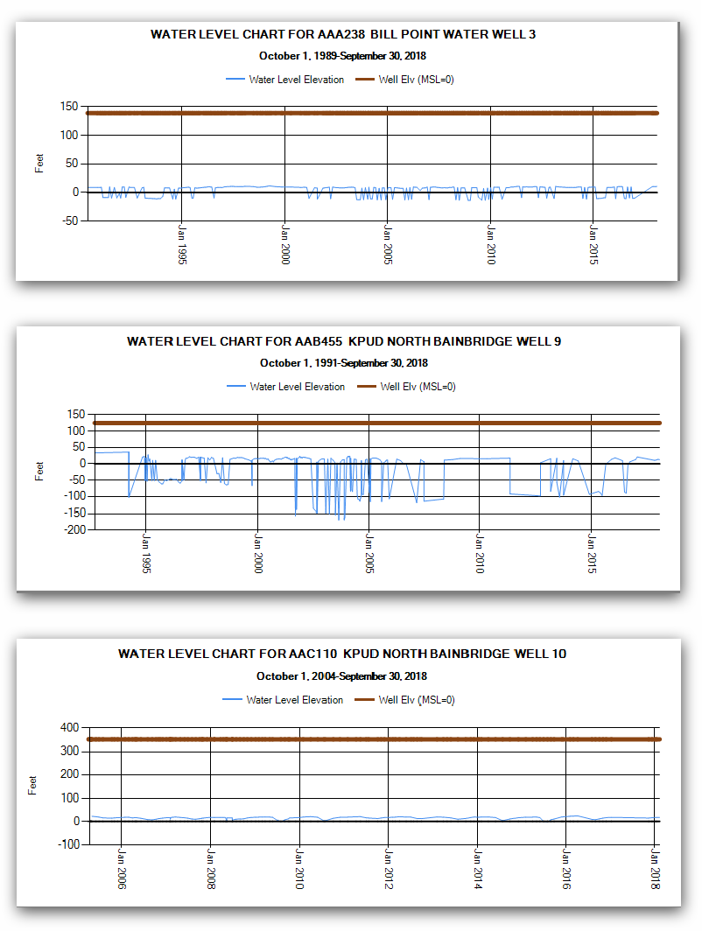

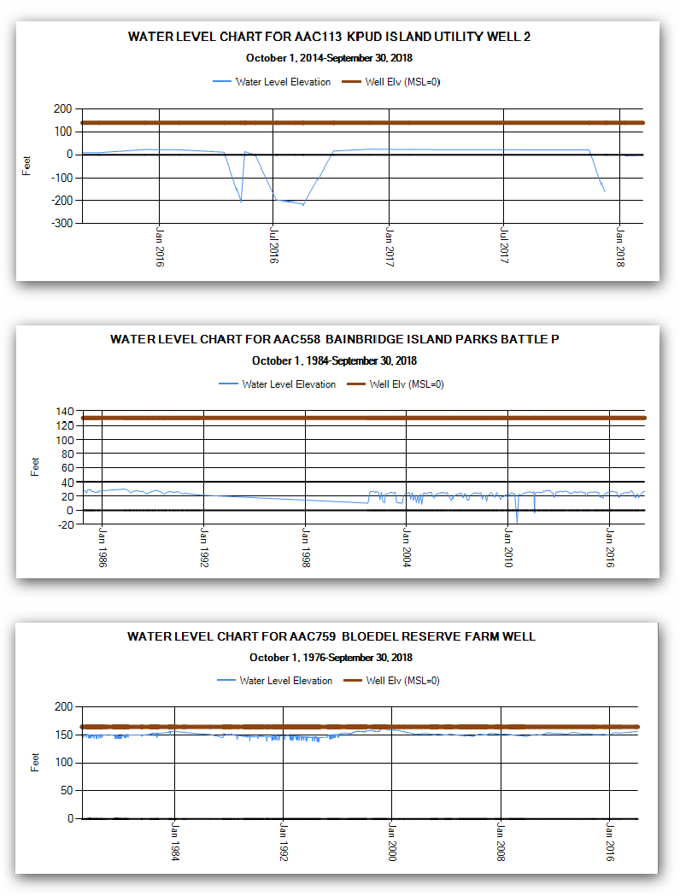

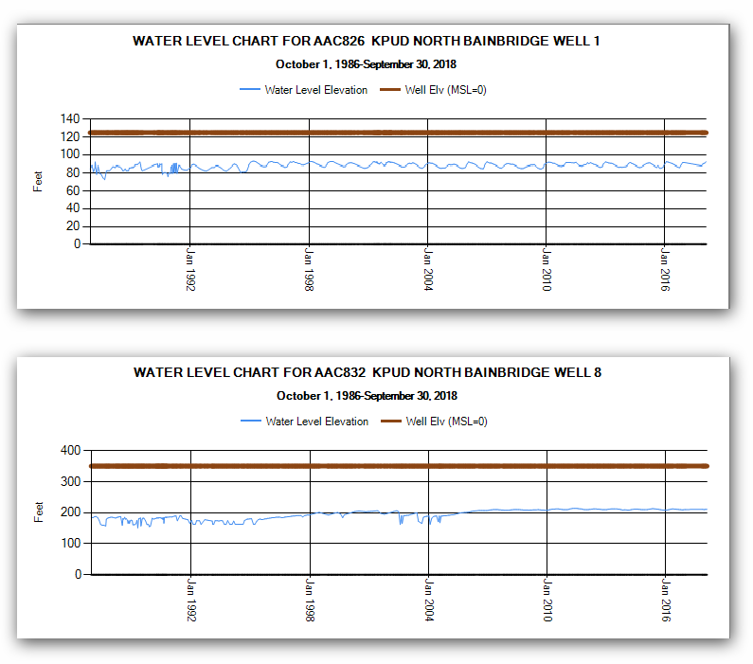

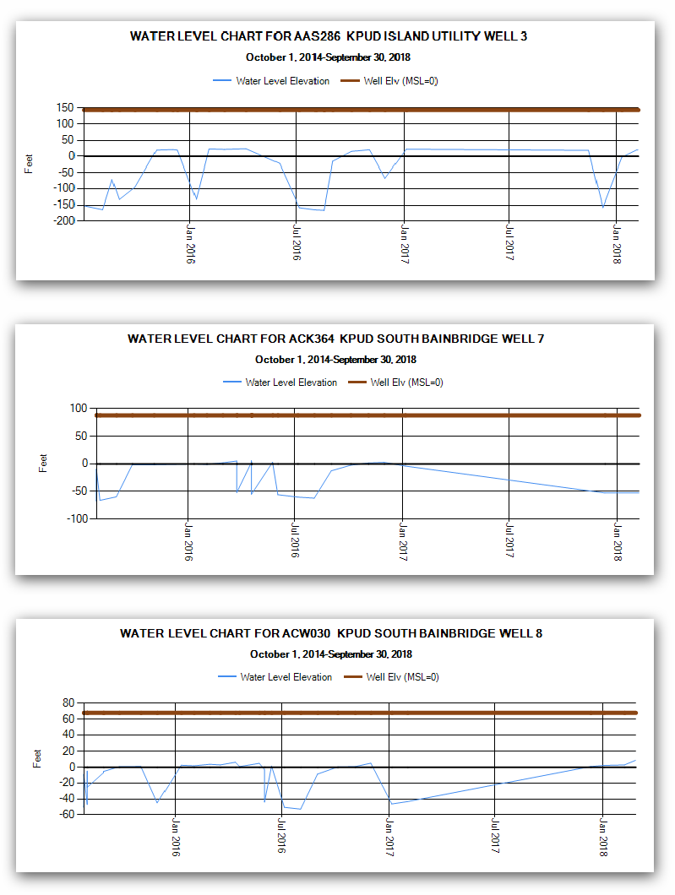

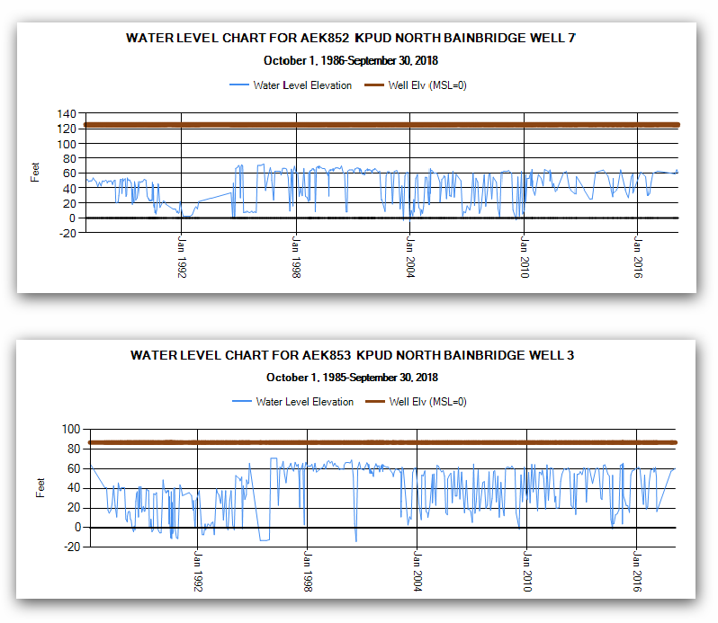

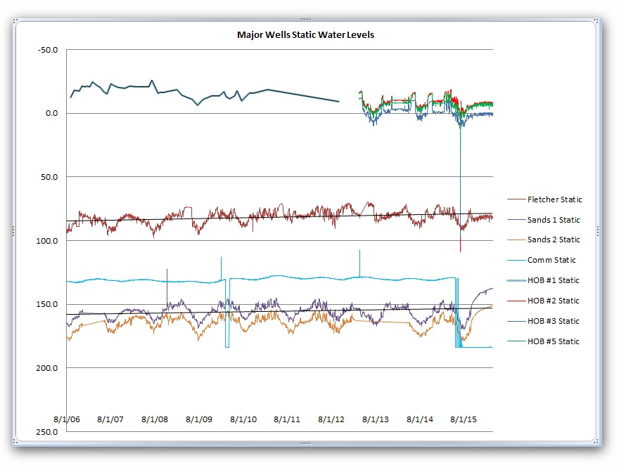

Appendix H: Groundwater Management Plan Content

Chapter 173-100-100 of the Washington Administrative Code (WAC) on “Groundwater Management Areas and Programs” states the following for “Groundwater management program content”:

The program for each groundwater management area will be tailored to the specific conditions of the area. The following guidelines on program content are intended to serve as a general framework for the program, to be adapted to the particular needs of each area. Each program shall include, as appropriate, the following:

(1) An area characterization section comprised of:

- A delineation of the groundwater area, subarea or depth zone boundaries and the rationale for those boundaries;

- A map showing the jurisdictional boundaries of all state, local, tribal, and federal governments within the groundwater management area;

- Land and water use management authorities, policies, goals and responsibilities of state, local, tribal, and federal governments that may affect the area's groundwater quality and quantity;

- A general description of the locale, including a brief description of the topography, geology, climate, population, land use, water use and water resources;

- A description of the area's hydrogeology, including the delineation of aquifers, aquitards, hydrogeologic cross-sections, porosity and horizontal and vertical permeability estimates, direction and quantity of groundwater flow, water-table contour and potentiometric maps by aquifer, locations of wells, perennial streams and springs, the locations of aquifer recharge and discharge areas, and the distribution and quantity of natural and man-induced aquifer recharge and discharge;

- Characterization of the historical and existing groundwater quality;

- Estimates of the historical and current rates of groundwater use and purposes of such use within the area;

- Projections of groundwater supply needs and rates of withdrawal based upon alternative population and land use projections;

- References including sources of data, methods and accuracy of measurements, quality control used in data collection and measurement programs, and documentation for and construction details of any computer models used.

(2) A problem definition section that discusses land and water use activities potentially affecting the groundwater quality or quantity of the area. These activities may include but are not limited to:

- Commercial, municipal, and industrial discharges

- Underground or surface storage of harmful materials in containers susceptible to leakage

- Accidental spills

- Waste disposal, including liquid, solid, and hazardous waste

- Storm water disposal

- Mining Activities

- Application and storage of roadway deicing chemicals

- Agricultural activities

- Artificial recharge of the aquifer by injection wells, seepage ponds, land spreading, or irrigation

- Aquifer over-utilization causing seawater intrusion, other contamination, water table declines or depletion of surface waters

- Improperly constructed or abandoned wells

- Confined animal feeding activities

The discussion should define the extent of the groundwater problems caused or potentially caused by each activity, including effects which may extend across groundwater management area boundaries, supported by as much documentation as possible. The section should analyze historical trends in water quality in terms of their likely causes, document declining water table levels and other water use conflicts, establish the relationship between water withdrawal distribution and rates and water level changes within each aquifer or zone, and predict the likelihood of future problems and conflicts if no action is taken. The discussion should also identify land and water use management policies that affect groundwater quality and quantity in the area. Areas where insufficient data exists to define the nature and extent of existing or potential groundwater problems shall be documented.

(3) A section identifying water quantity and quality goals and objectives for the area which

- Recognize existing and future uses of the aquifer,

- Are in accordance with water quality standards of the department, the department of social and health services, and the federal environmental protection agency, and

- Recognize annual variations in aquifer recharge and other significant Hydrogeologic factors.

(4) An alternatives section outlining various land and water use management strategies for reaching the program's goals and objectives that address each of the groundwater problems discussed in the problem definition section. If necessary, alternative data collection and analysis programs shall be defined to enable better characterization of the groundwater and potential quality and quantity problems. Each of the alternative strategies shall be evaluated in terms of feasibility, effectiveness, cost, time and difficulty to implement, and degree of consistency with local comprehensive plans and water management programs such as the coordinated water system plan, the water supply reservation program, and others. The alternative management strategies shall address water conservation, conflicts with existing water rights and minimum instream flow requirements, programs to resolve such conflicts, and long-term policies and construction practices necessary to protect existing water rights and subsequent facilities installed in accordance with the groundwater management area program and/or other water right procedures.

(5) A recommendations section containing those management strategies chosen from the alternatives section that are recommended for implementation. The rationale for choosing these strategies as opposed to the other alternatives identified shall be given;

(6) An implementation section comprised of:

- A detailed work plan for implementing each aspect of the groundwater management strategies as presented in the recommendations section. For each recommended management action, the parties responsible for initiating the action and a schedule for implementation shall be identified. Where possible, the implementation plan should include specifically worded statements such as model ordinances, recommended governmental policy statements, interagency agreements, proposed legislative changes, and proposed amendments to local comprehensive plans, coordinated water system plans, basin management programs, and others as appropriate;

- A monitoring system for evaluating the effectiveness of the program;

- A process for the periodic review and revision of the GWMP.

The above outline is meant to provide a general guideline for the type of information included in a GWMP. The information for the Bainbridge Island GWMP should be tailored to the specific needs of COBI for making decisions about its groundwater resource. Several items listed above will not be relevant to Bainbridge Island while other items should be added. Some items to be added include:

- A detailed breakdown of categories of water use, including residential, commercial, industrial, and agricultural. For the residential category it would be helpful to obtain a good estimate of indoor versus outdoor usage.

- A breakdown of usage/pumping from larger COBI, KPUD, or community wells and usage/pumping from small exempt domestic wells.

Appendix I: Groundwater Management Plan Experience

King County:

South King County – Draft completed in 2003 but never certified nor approved. Its implementation is limited to water purveyors and thus, the implementation is far less then described in their GWMP.

Issaquah Creek Valley -- Plan approved 1999 and implemented in the early 2000‟s. It became inactive as of 2007 due to lack of funding. The paired back activity deemed to be of value was merged into existing groundwater monitoring programs for Sammamish.

East King County -- Plan approved 1999 and implemented in the early 2000‟s. It became inactive as of 2004 due to funding issues. No current actions being conducted.

Redmond-Bear Creek Valley -- Plan approved 1999 and implemented in the early 2000‟s. It became inactive as of 2007 due to funding issues. No county coordinated activities currently being conducted. Data collection is limited to water purveyors and cities.

Vashon-Maury Island – Plan approved 2000 and has been pared back to a well monitoring plan which is presently active. The impetus for the implementation of the plan was discovery of chlorine levels in a few wells on the island. This problem has not persisted. The GWMP was approved and implemented which includes an oversight Committee. Primary concern is with growth impacts as it related to: overuse, contamination (land-use activities [i.e. pesticides] and septic concerns), saltwater intrusion, and loss of recharge zones. The groundwater monitoring program, which has an annual cost of approximately $200,000, consists of:

- 24 sites for water quality on an annual basis

- 9 monitoring wells have water level data loggers providing daily data – downloaded quarterly

- self-monitoring volunteers who take monthly water levels and monthly meter readings

The estimate for the entire program as envisioned in 1998 was $500,000 at that time.

Island County:

Island County experienced significant sea water intrusion issues at several of their coastal wells. Benefiting from King County’s experience they decided to address their problem through a watershed planning process. They became the first county in the state to develop a sea water intrusion policy not using chloride as the primary indicator. Instead they created an Island County Code with two prongs for evaluating sea water intrusion risks. Primarily they are using the trend of in-well measured high water level elevations. They developed a matrix where projects are rated for risk and go through a sea water intrusion planning process. They established water level criteria which are designed to prevent sweater intrusion. They monitor 60 wells and are funded through a clean water utility tax.

Kitsap County:

Kitsap County developed a Groundwater Management Plan in 1991. This recommended a hydrologic monitoring network which Kitsap PUD established and presently maintains. It currently consists of 28 precipitation monitoring sites, 28 stream flow monitoring sites, 128 groundwater (level) monitoring sites and 80 sites that are monitored (semi-annually) for seawater intrusion (link: http://kpudhydrodata.kpud.org/). The purpose of the network is to provide information relevant to understanding long term sustainability of groundwater resources. In addition, Kitsap PUD owns and operates 27 “Group A” public water systems. For these systems they do not rely on EWLs but maintain a focus on well water levels for short term sustainable production goals. Source wells for these systems are routinely monitored for water quality as required by the Safe Drinking Water Act. Kitsap PUD has 2 FTEs allocated to the monitoring network at an annual cost of approximately $238,000.

